Referral for: Left Atrial Appendage Closure with Non-Valvular Atrial Fibrillation.
From: ________________________________________ Contact #: ________________________________________
Patient Name: __________________________________________ DOB: ____________________________________
The above referenced patient is being referred to the Cooper Structural Heart Disease Program for evaluation for Left Atrial Appendage Closure with Watchman device for management of stroke risk resulting from non-valvular atrial fibrillation.
Based on ______________________ past history, it has been determined that he / she is a poor candidate for long-term oral-anticoagulation, however may be tolerant of short term treatment with warfarin as necessary.
HAS BLED  (Bleeding Risk with Warfarin) | Points |  | Score | Yearly Major Bleeding Risk (%)
Hypertension (SBP > 160) | 1 |  | 0 | 1.13
Abnormal renal/liver function (1 point each) | 1 or 2 |  | 1 | 1.02
Stroke | 1 |  | 2 | 1.88
Bleeding History or disposition | 1 |  | 3 | 3.74
Labile INR | 1 |  | 4 | 8.70
Elderly (Age > 65 Years) | 1 |  | 5+ | 12.5
Drugs (medication) or alcohol use (1 point each) | 1 or 2
CHA2 DS2 VASc | Point |  | Score | Yearly Stroke Risk %
Congestive Heart Failure | 1 |  | 0 | 0
Hypertension (SBP > 160) | 1 |  | 1 | 1.3
Age > 75 Years | 2 |  | 2 | 2.2
Diabetes mellitus | 1 |  | 3 | 3.2
Prior stroke, TIA or thromboembolism | 2 |  | 4 | 4.0
Vascular disease  (PAD, MI) | 1 |  | 5 | 6.7
Age 65-74 | 1 |  | 6 | 9.8
Sex category (Female) | 1 |  | 7 | 9.6
 |  |  | 8 | 6.7
 |  |  | 9 | 15.2
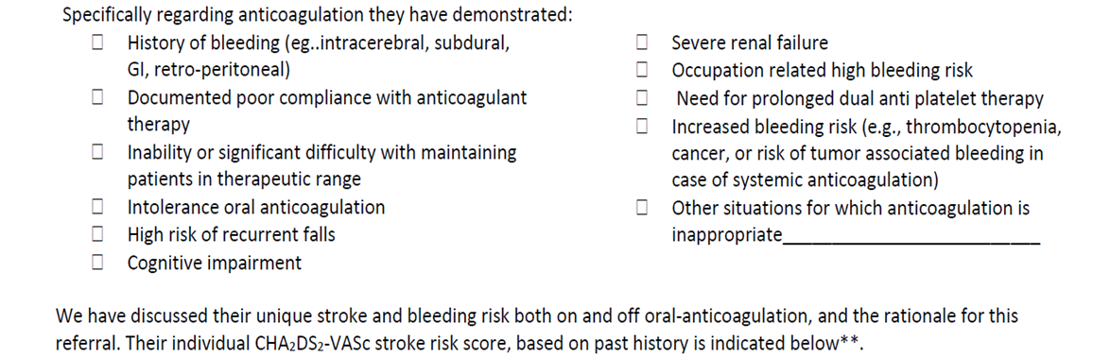

*Circle and total points, correlate patients with adjusted stroke rate. Based on both stroke and bleeding risk, a shared decision has been made to pursue closure of the left atrial appendage as a safe and effective alternative to oral anticoagulant therapy for stroke prophylaxis and to reduce their long-term risk of incidence of intra cerebral bleeding.

The following tool was utilized in the shared decision process for this patient:
- Ottawa Personal Decision Guide
- ACC Shared Decision Tool
- NICE tool
- SPARC Tool

- SPARC tool

Non Interventional Physician Signature: _______________________________________Date: _____________
Please e- fax completed form to 856-735-6489
Payer: Pre Certification Status: Inpatient / Outpatient

Authorization #

